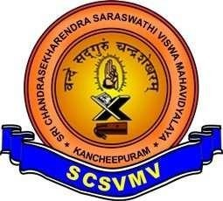

SRI CHANDRASEKHARENDRA SARASWATHI VISWA MAHAVIDYALAYA
(UNIVERSITY ESTABLISHED UNDER SECTION 3 OF UGC ACT 1956)
ENATHUR, KANCHIPURAM – 631 561

DEPARTMENT OF COMPUTER SCIENCE & ENGINEERING

Name : S.SARITHA_

Reg. No : 11249A333
Class : II B.E. (CSE)
Section :S4
Course Code: BCSF244A12
Course Name:Data Science ToolKit Lab


SRI CHANDRASEKHARENDRA SARASWATHI VISWA MAHAVIDYALAYA

(UNIVERSITY ESTABLISHED UNDER SECTION 3 OF UGC ACT 1956)
ENATHUR, KANCHIPURAM – 631 561
DEPARTMENT OF COMPUTER SCIENCE & ENGINEERING

BONAFIDE CERTIFICATE

This is to certify that this is the bonafide record of work done by
Mr/Ms. S.SARITHA ,

with Reg. No _11249A333 of II-B.E.(CSE) during the academic year 2025 – 2026.

Station:Enathur
Date:23-04-2026

Staff-in-charge Head of the Department

Submitted for the Practical examination held on .

Examiner-1 Examiner-2
INDEX

SL.NO | Name of the experiment | Date | Page no | Signature
01. | NUMPY, PANDAS, MATPLOTLIB, SCIKIT-LEARN PROGRAMS | 02-02-26
02. | PERFORM DATA EXPLORATION AND PREPROCESSING IN PYTHON.0 | 14-02-26
03. | IMPLEMENT REGULARIZED LINEAR REGRESSION. | 14-02-26
04. | IMPLEMENT NAÏVE BAYES CLASSIFICATION. | 23-02-26
05. | IMPLEMENT REGULARIZED LOGISTIC REGRESSION. | 02-03-26
06. | BUILD MODELS USING DIFFERENT ENSEMBLING TECHNIQUES. | 09-03-26
07. | BUILD MODELS USING DECISION TREES. | 16-03-26
08. | SVM WITH DIFFERENT KERNELS. | 16-03-26
09. | IMPLEMENT KNN CLASSIFICATION. | 23-03-26
10. | K-MEANS CLUSTERING WITH PCA AND ELBOW METHOD | 23-03-26

NUMPY,PANDAS,MATPLOTLIB,SCIKIT-LEARN PROGRAMS
EXP NO:01
DATE:02-02-2026

AIM:To study and visualize data using matplotlib library in python

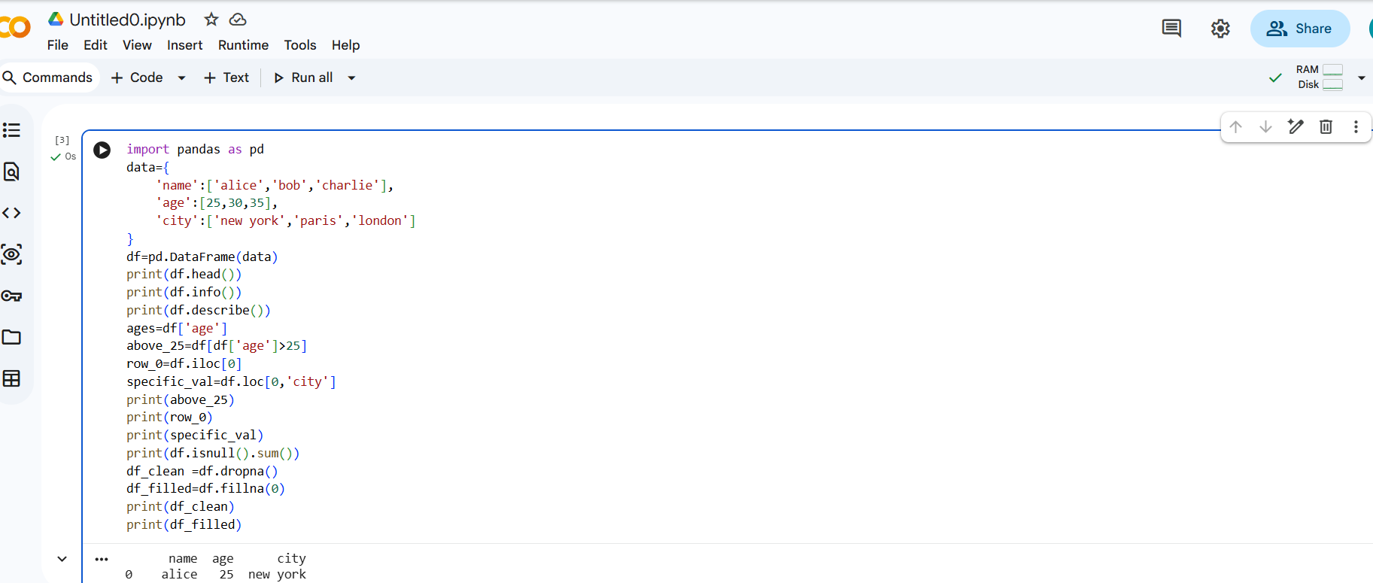

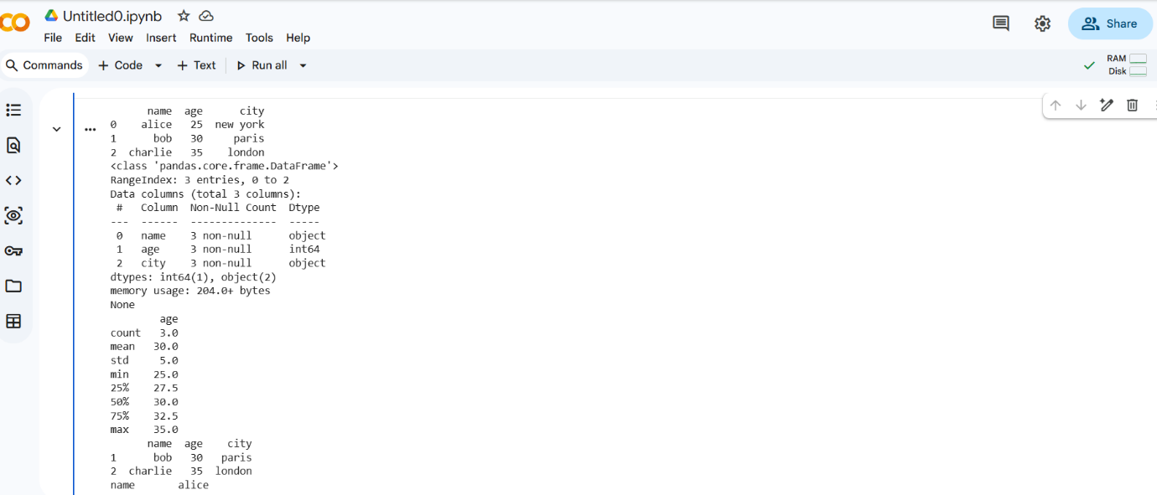

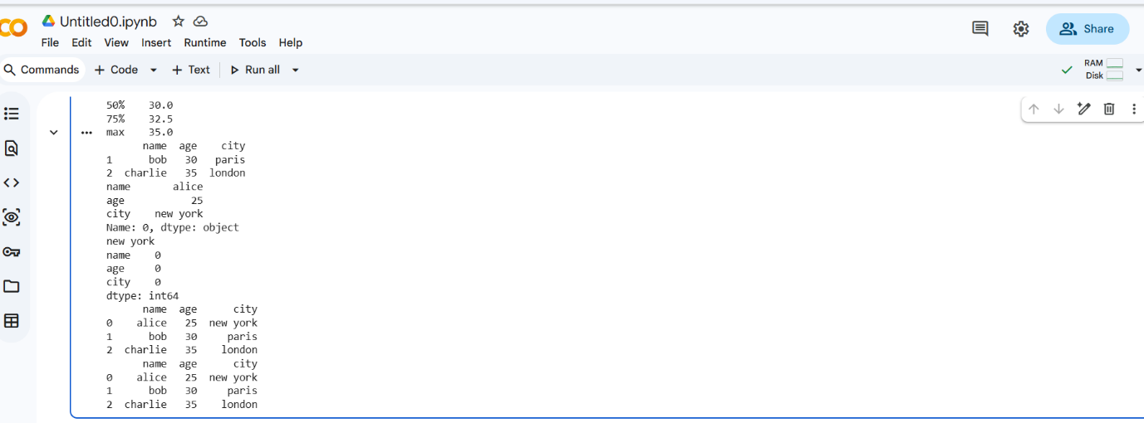

MATPLOTLIB

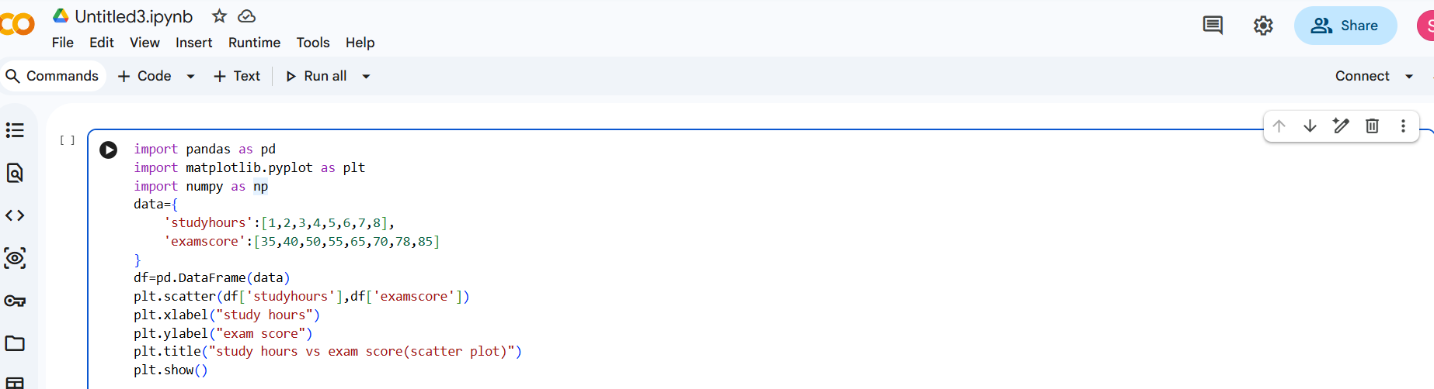

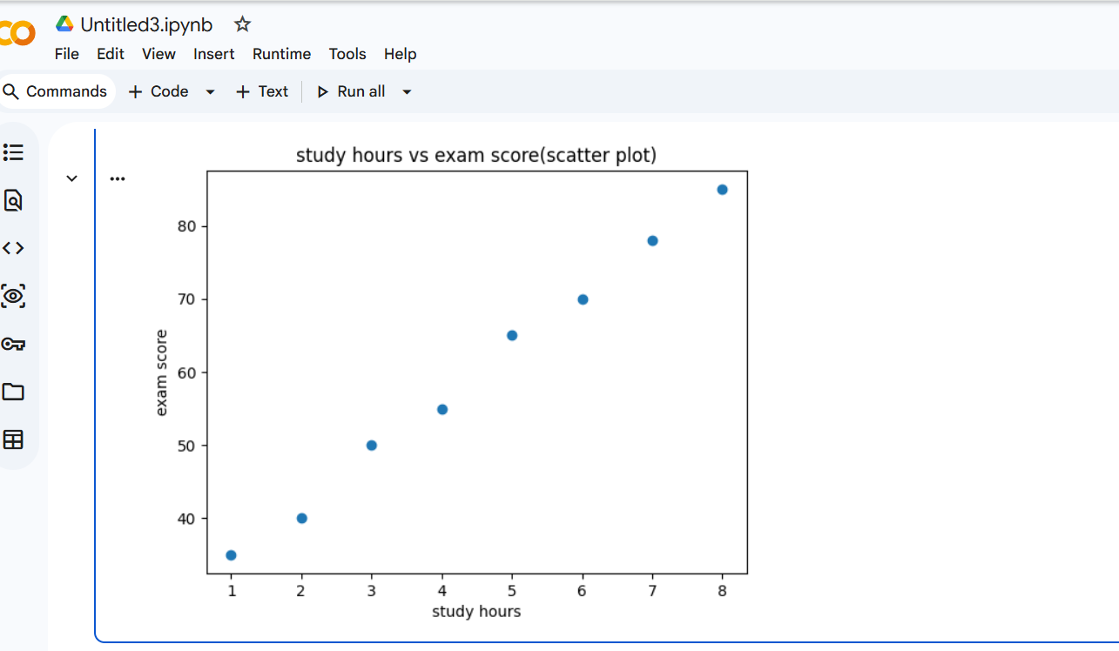

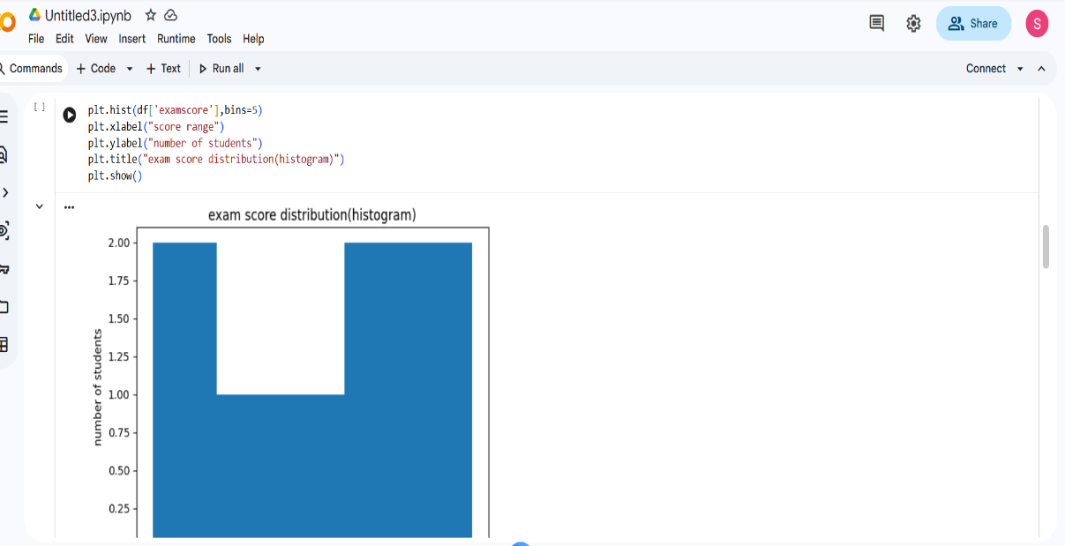
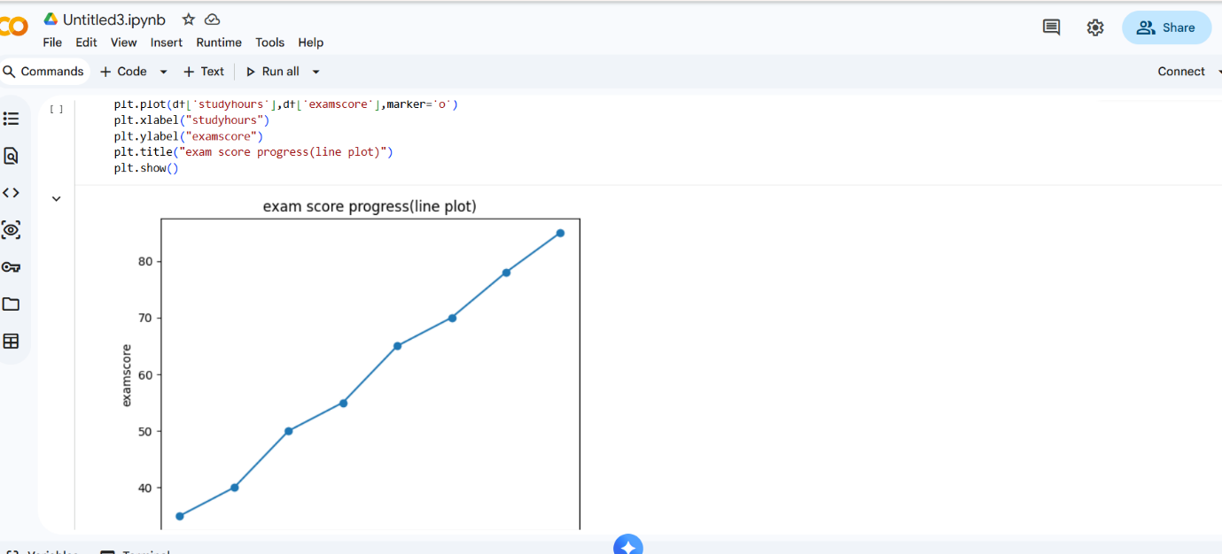
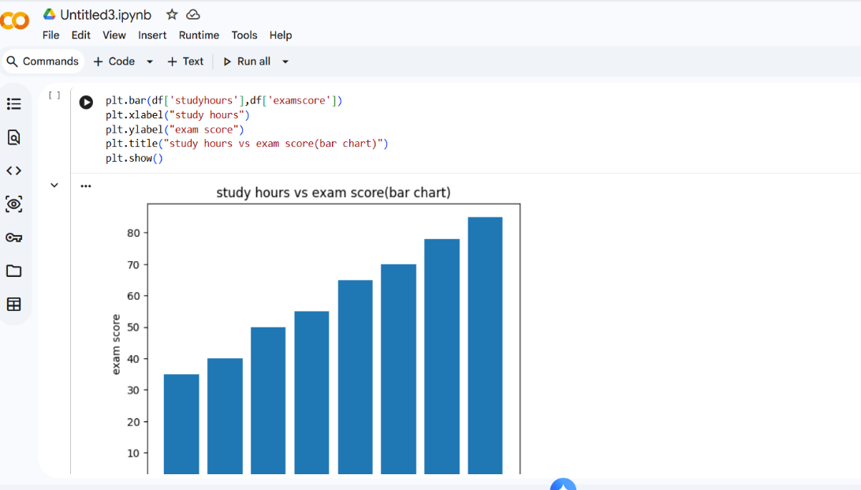
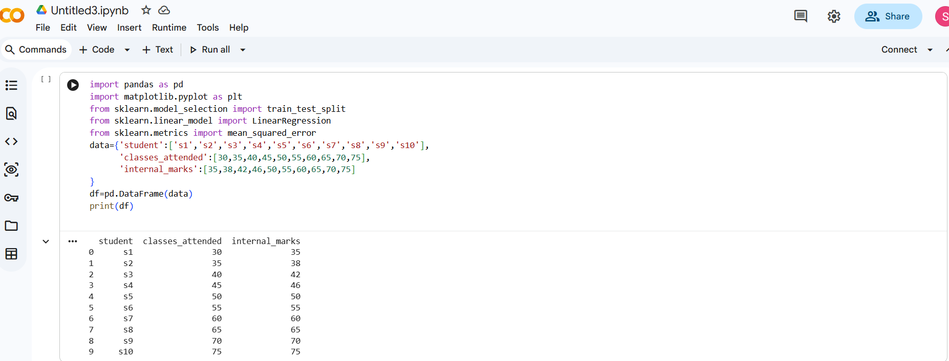

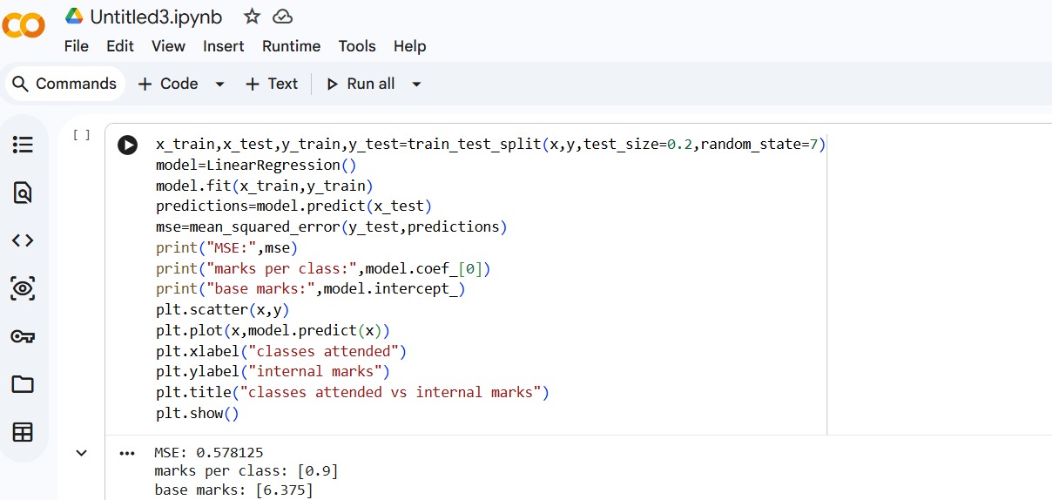

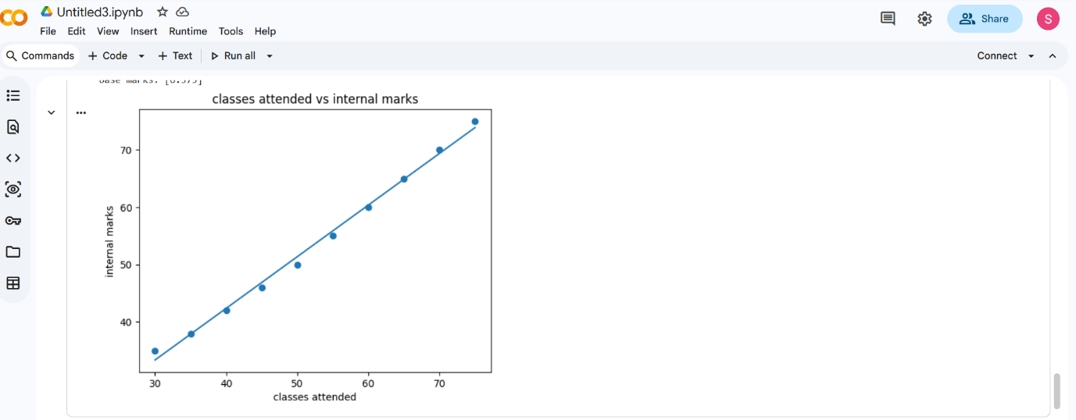

RESULT:Successfully plotted different types of graphs and understood data visualization techniques

DATA EXPLORATION AND PREPROCESSING IN PYTHON

EXPNO:02
DATE:14-02-2026

AIM:To perform data exploration and preprocessing5 using python libraries like pandas and numpy

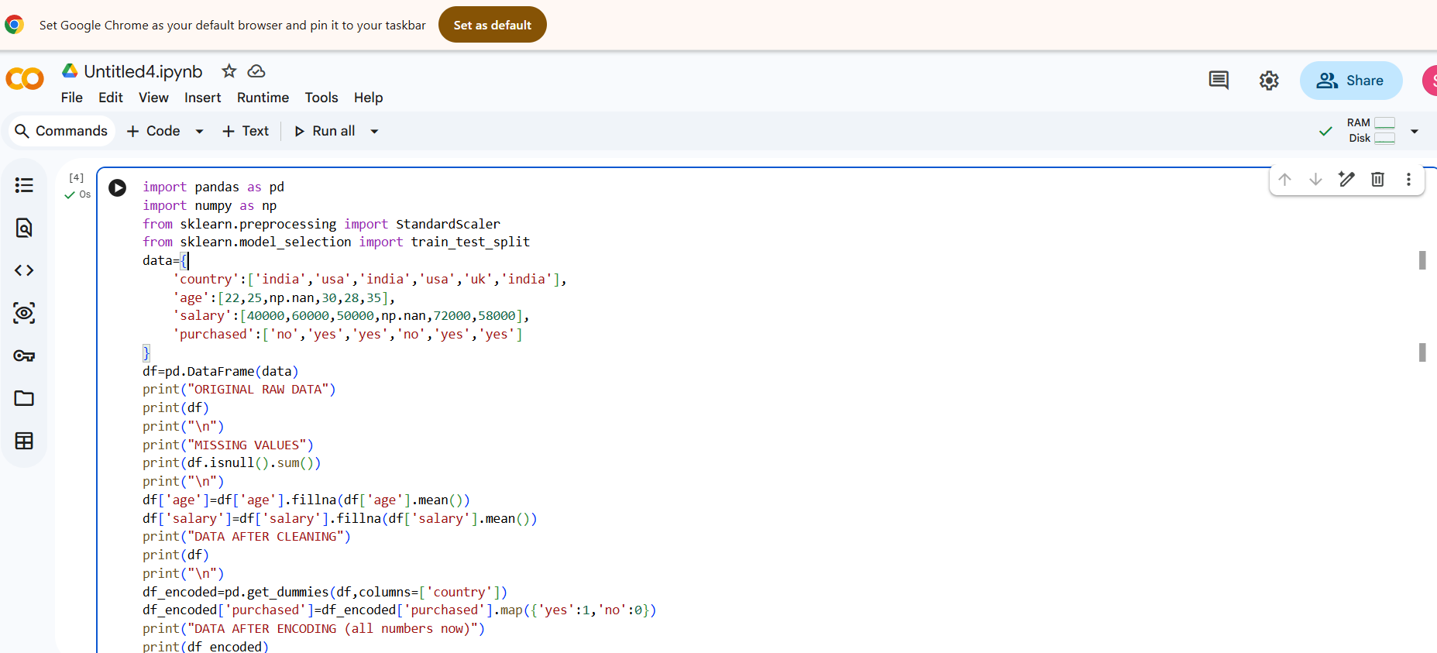
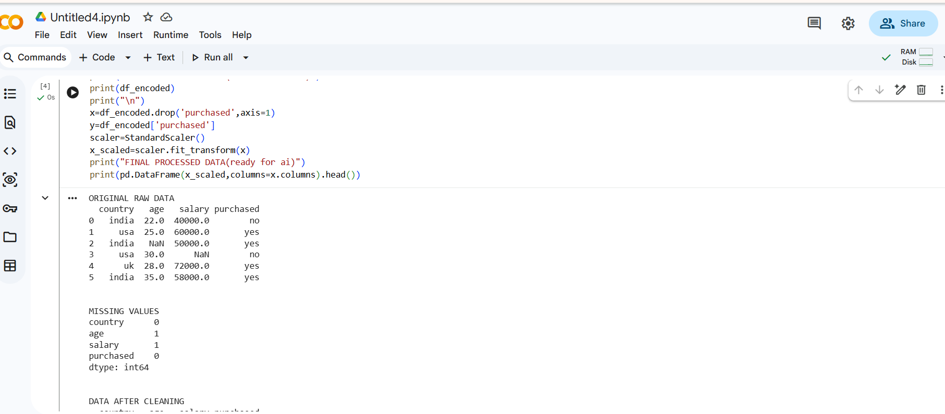
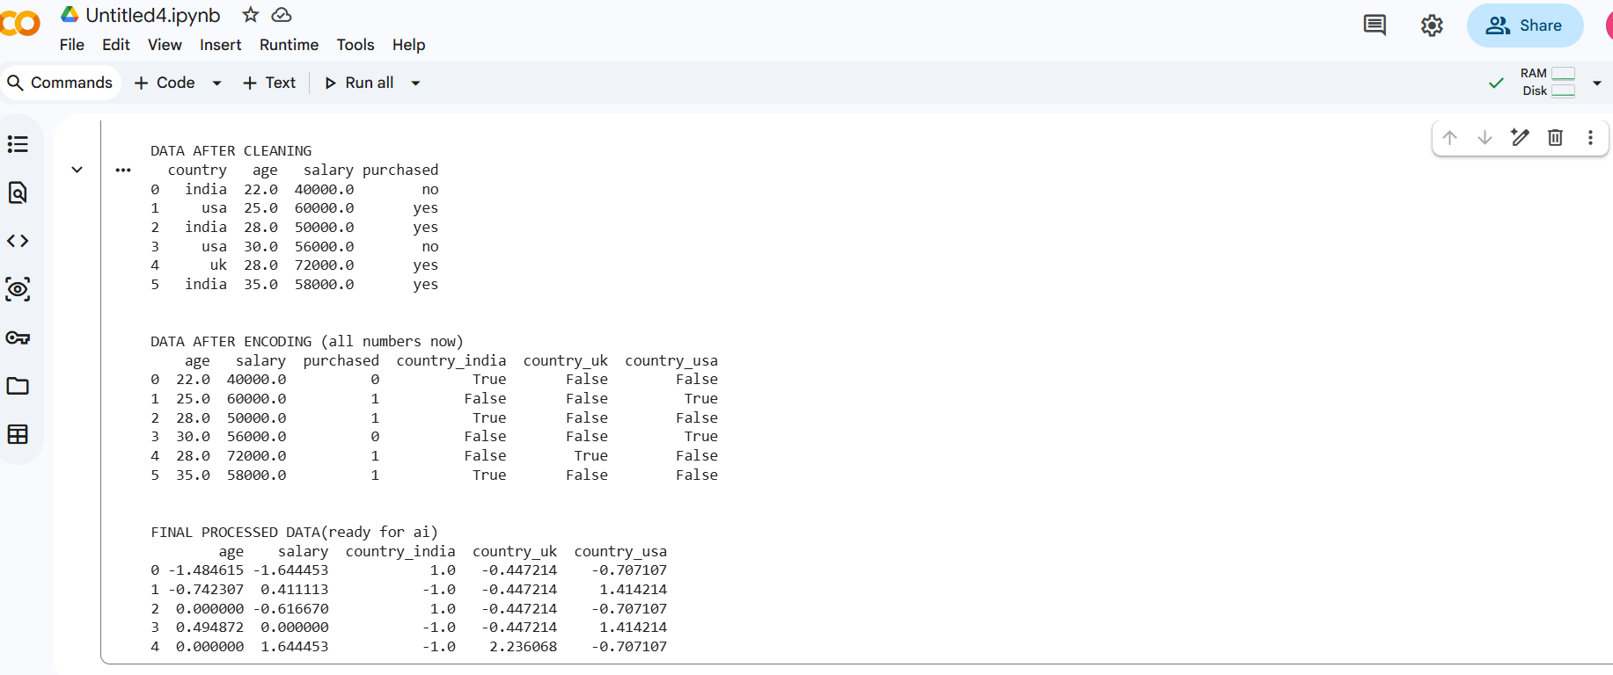

RESULT:Successfully cleaned,transformed and analyzed and dataset by handling missing values and preparing it for modeling

IMPLEMENT REGULARIZED LINEAR REGRESSION
EXP NO:03
DATE:14-02-2026

AIM:To implement regularization to reduce overfitting and improved model peformance

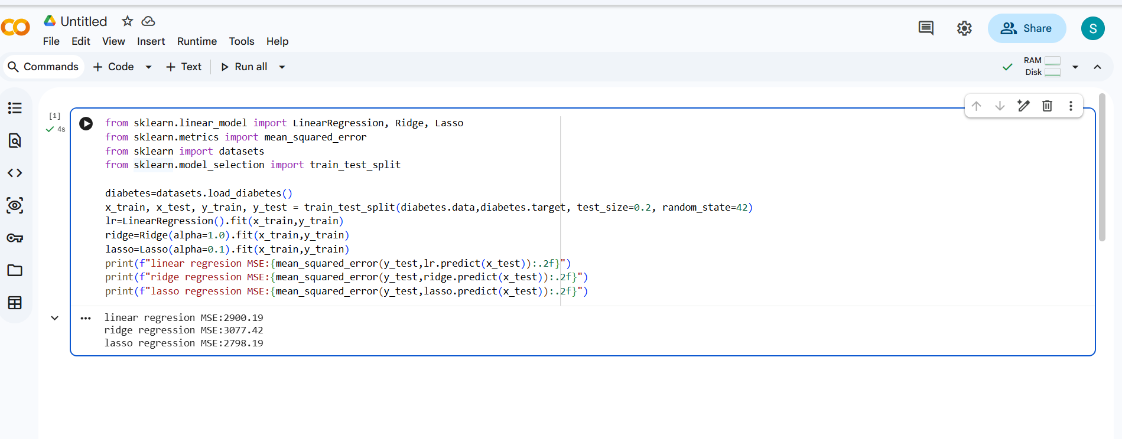

RESULT:Successfully applied regularization to reduce overfitting and improved model performance

IMPLEMENT NAIVE BAYES CLASSIFICATION
EXP NO:04
DATE:23-02-2026

AIM:To implement Naïve Bayes classification for predicting class labels

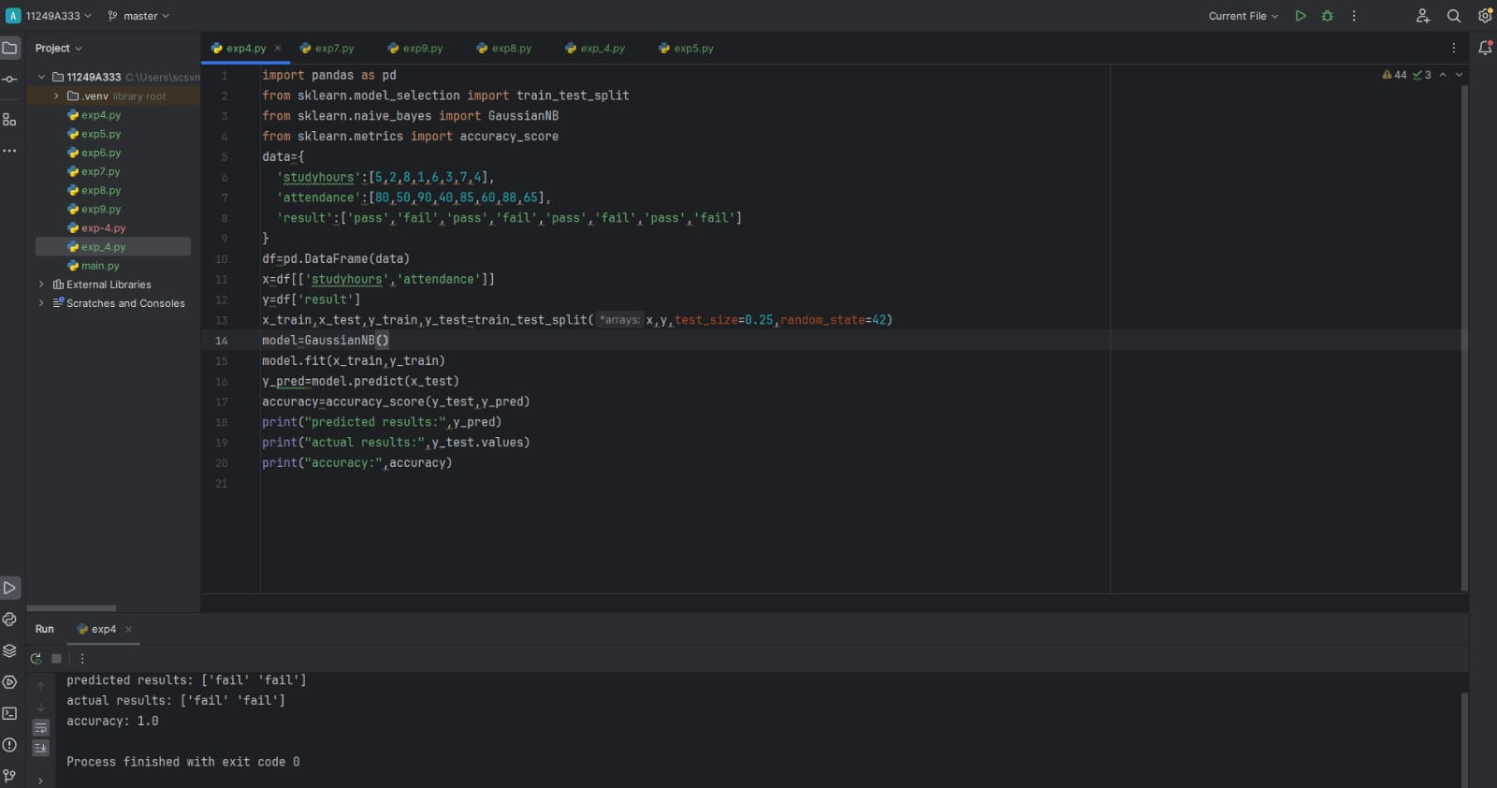

RESULT:Successfully built a probabilistic classifier and achieved accurate predictions on the dataset

IMPLEMENT REGULARIZED LOGISTIC REGRESSION
EXP NO:05
DATE:02-03-2026

AIM: To implement Regularized Logistic Regression using Python and analyze the effect of regularization in reducing overfitting and improving model performance.

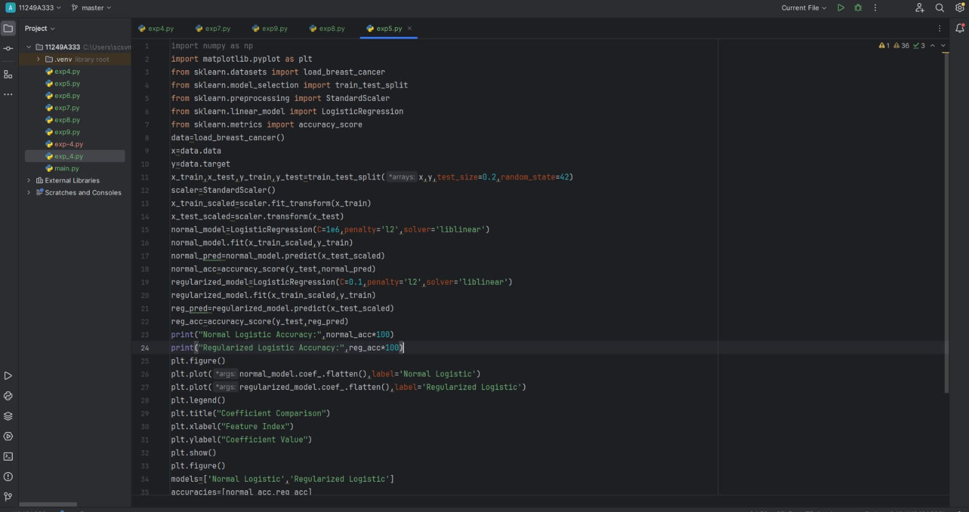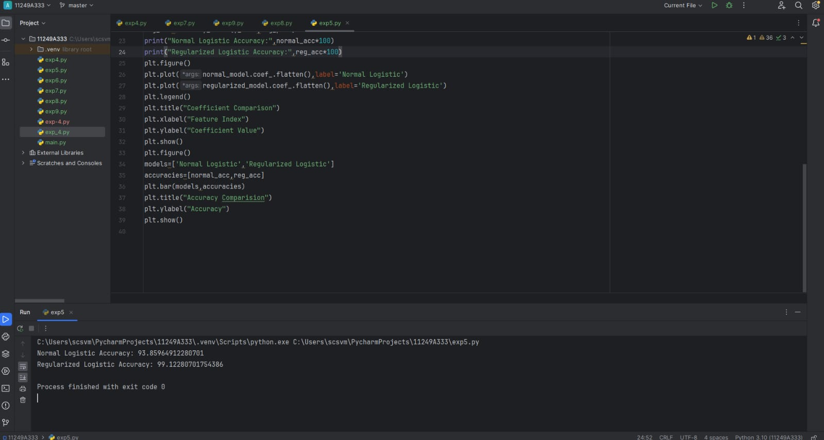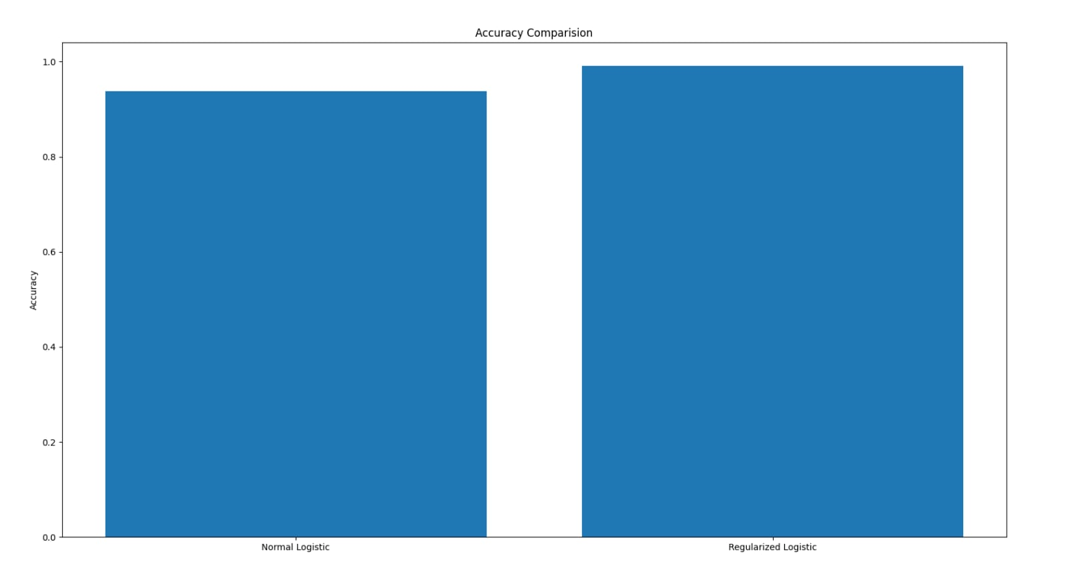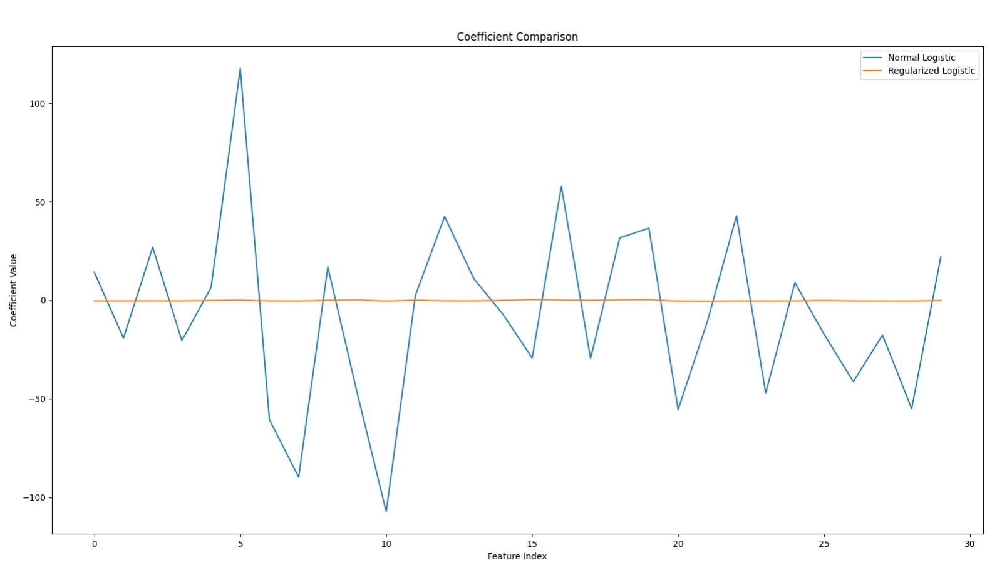

RESULT: Successfully implemented Regularized Logistic Regression and observed that regularization improves generalization by controlling model complexity, leading to better prediction accuracy on test data.

BUILD MODELS USING DIFFERENT ENSEMBLING TECHNIQUES

EXP NO:06
DATE:09-03-2026
AIM: To build models using different ensemble techniques like Bagging, Boosting, and Random Forest.

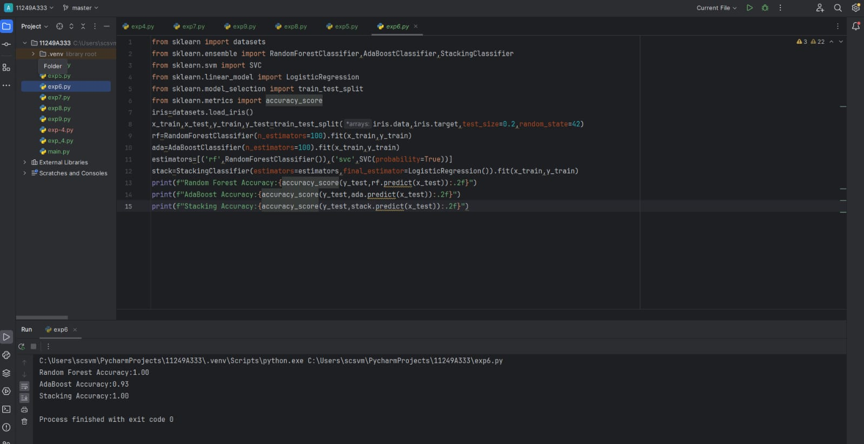

RESULT: Successfully improved prediction accuracy by combining multiple models.

BUILD MODELS USING DECISION TREES
EXP NO:07
DATE:16-03-2026
AIM: To build and analyze models using Decision Tree algorithms.

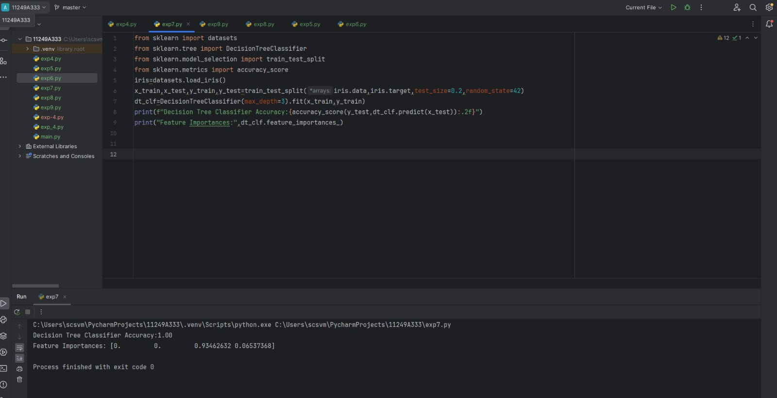

RESULT: Successfully created decision tree models and interpreted decision rules for classification.

SUPPORT VECTOR MACHINES(SVM)WITH DIFFERENT KERNELS
EXP NO:08
DATE:16-03-2026
AIM: To implement SVM with different kernels (linear, polynomial, RBF).

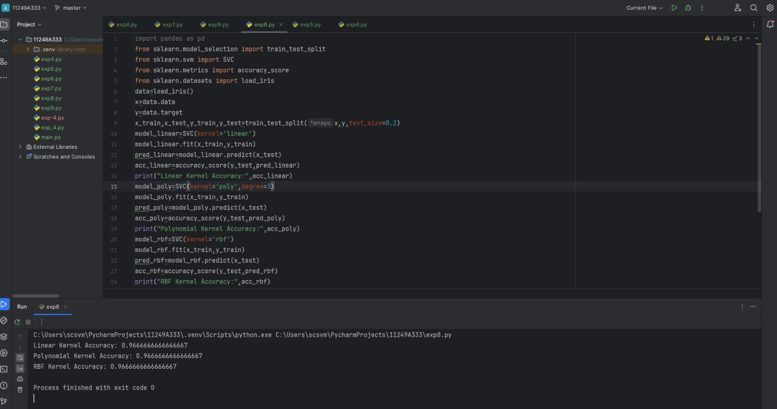

RESULT: Successfully classified data using SVM and compared performance of different kernels.

IMPLEMENT KNN CLASSIFICATION
EXPNO:09
DATE:23-03-2026
AIM: To implement KNN classification algorithm

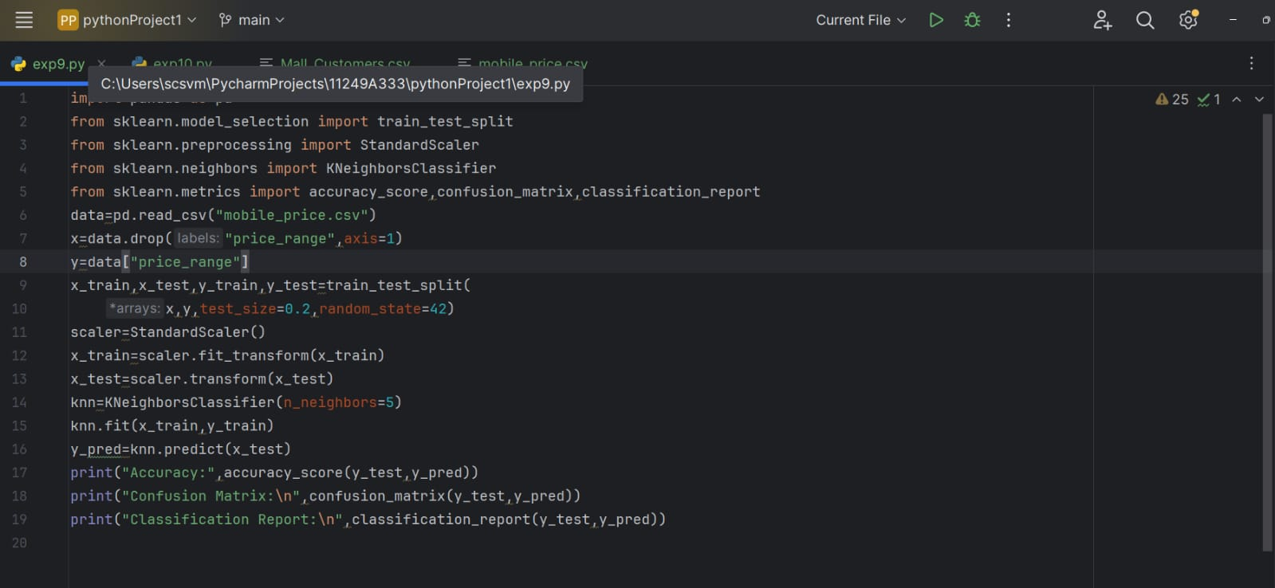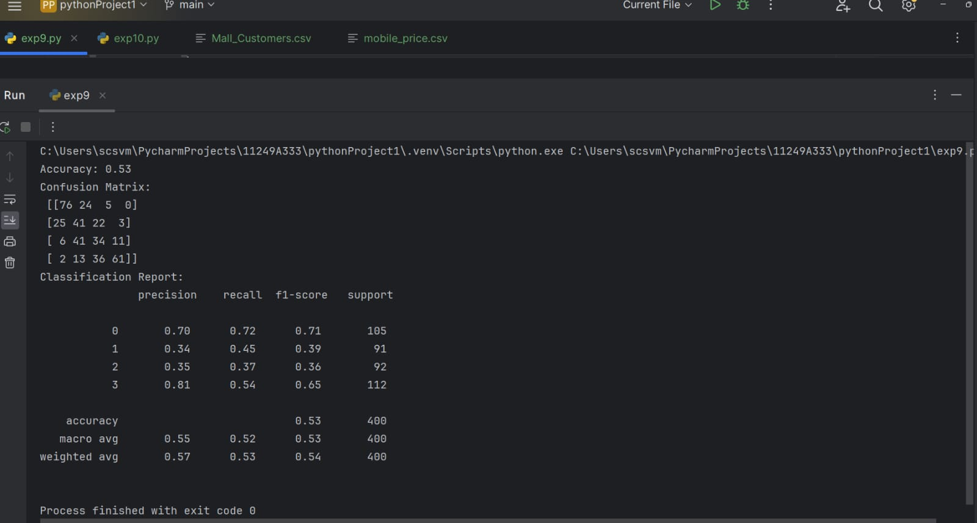
RESULT: Successfully classified data based on nearest neighbors and analyzed the effect of K values.
K MEANS CLUSTERING WITH PCA AND ELBOW METHOD
EXP NO:10
DATE:23-03-2026
AIM:To perform K-Means clustering and determine optimal clusters using PCA and Elbow method

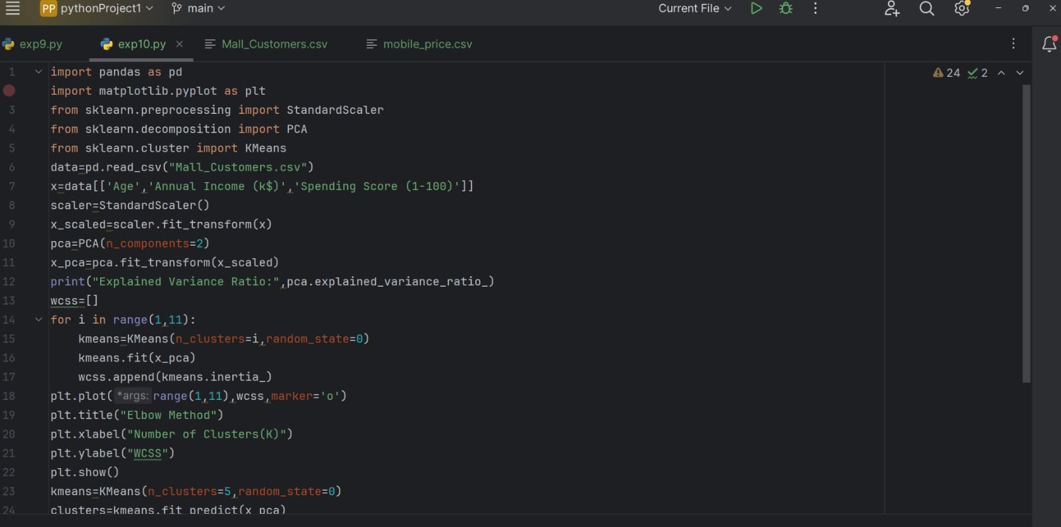

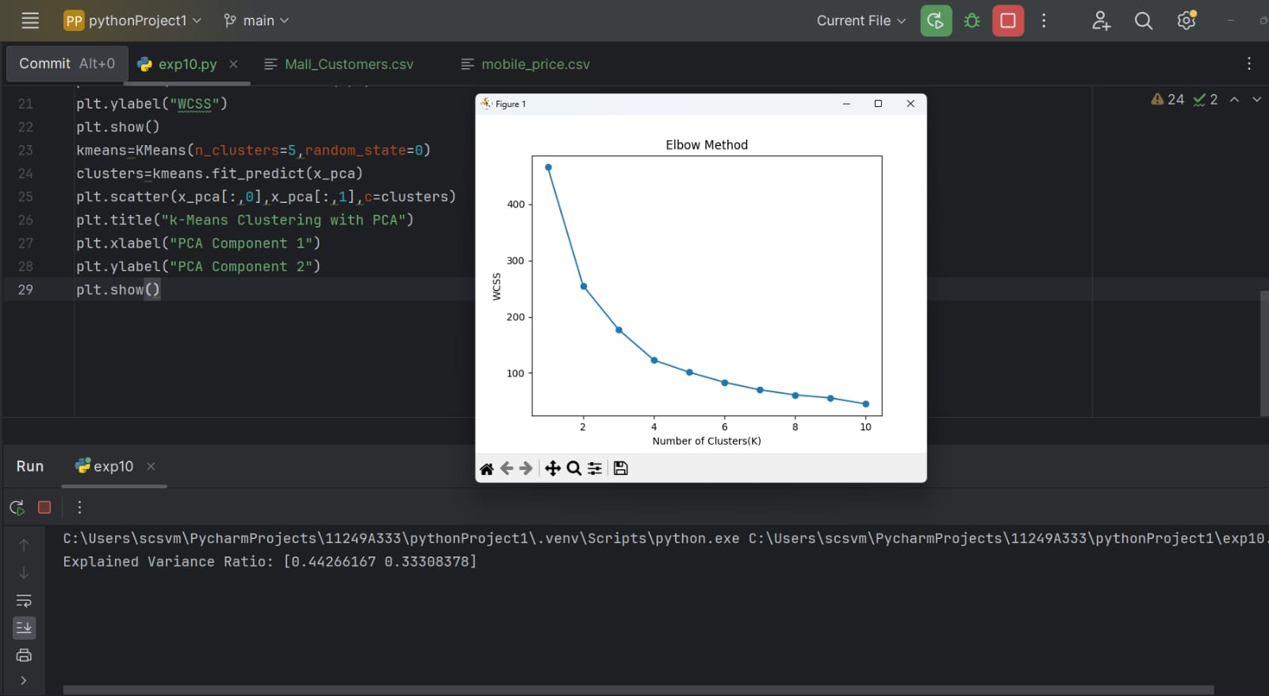
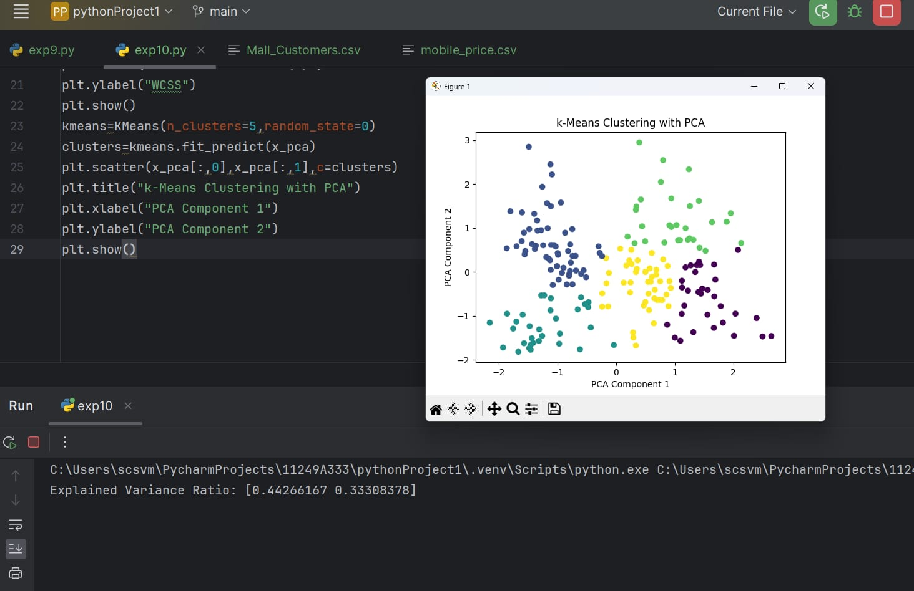

RESULT: Successfully reduced dimensionality using PCA and identified optimal clusters using the Elbow method.

